**Create simple product management application.**

**Notes –**

1. **Create application using MVC / .NET Webforms**
2. **Add validations**

**Summary:**

1. **Database structure (10 Marks)**
2. **Product listing page (10 Marks)**
3. **Product create page (10 Marks)**
4. **Product edit page (15 Marks)**
5. **Product delete page (10 Marks)**
6. **Dropdown binding (5 Marks)**
7. **Shipping cost calculation (10 Marks)**
8. **Trim Product Description (10 Marks)**
9. **Validations (5 Marks)**
10. **File Upload (15 Marks)**

Design below form and save data in database on click of “Add Product” button.

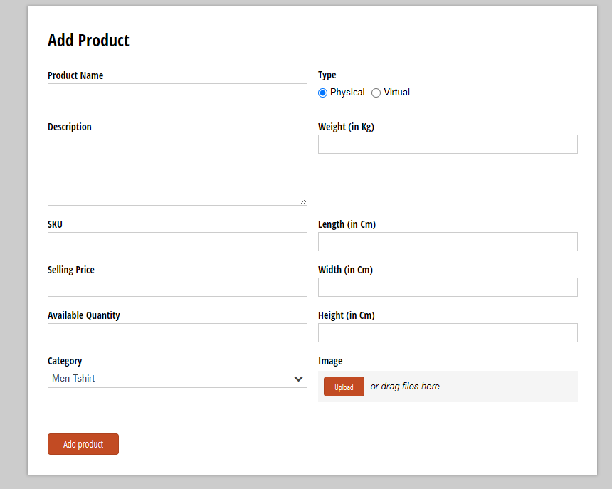

- In above form show Weight, Length, Width and Height textboxes only when type is Physical.

- Save above details in Products table.

- Category should come from categories master table.

- When saving above details save shipping cost also in shipping cost column, after calculation.

- While uploading file it should only accept .PNG, .JPG, .JPEG file formats

**Formula to calculate shipping cost –**

1. Physical product shipping cost calculation formulas = weight * 50 (here weight can be actual weight or volumetric weight whichever is higher)

Volumetric weight formula = (length * width * height)/5000

2. Virtual Product shipping cost - Rs. 50 or 10% of selling price whichever is higher.

**Tables schema should be as below –**

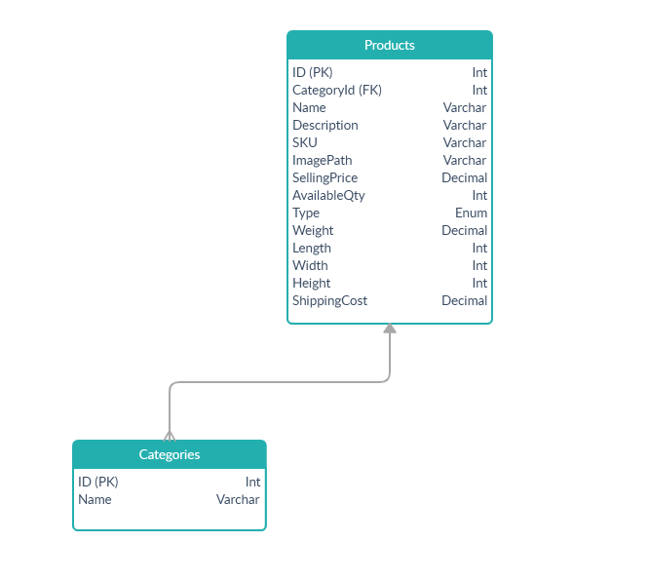

**Design page to show all the saved products like below –**

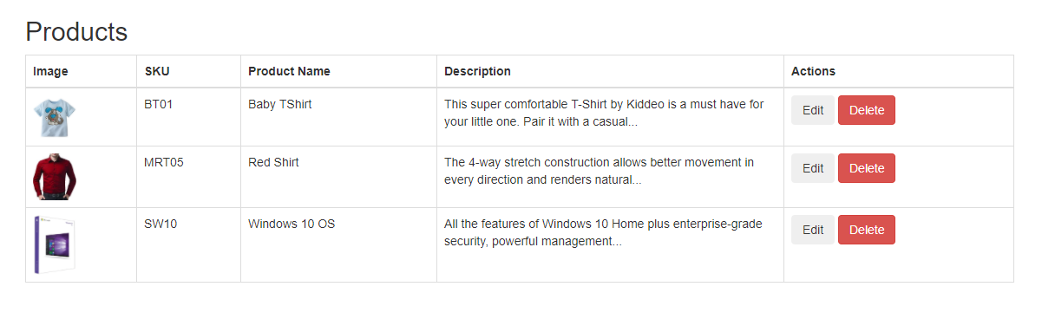

1. **“Trim Description”** - In above page Show only first 100 characters of description in such a way that 100th character should not break any word, if it is breaking any word then show only characters before that word and append '...' after the new string.

For E.g. if the description is "The 4-way stretch construction allows better movement in every direction and renders natural movement. Its stretch construction enhances mobility for a superior range of motion that makes it better from other seller’s tank tops."

100 characters of above string is "The 4-way stretch construction allows better movement in every direction and renders natural movemen", here the 100th character cutting the word "movement", so the resulting description should be

"The 4-way stretch construction allows better movement in every direction and renders natural..."

2. On click of edit button open edit form where user can **edit and save the details**. On edit shipping cost should get recalculated based on new parameters.

3. On click of delete show confirmation box and after user confirms, **delete the product from db** and refresh the products page.